Project management philosophy:

The biggest limiting resource in our project is the amount of time we have available to complete it, and so efficiently utilising the time we have was the biggest focus in creating and refining out project plan and gantt chart. This lead to the decision to take advantage of the critical path method (CPM). To generate the task list for the CPM, a work breakdown structure was produced.

A model of the project was constructed comprising of the following elements:

* A task list of all activities required to complete the project
* The duration of each task
* Dependencies between each task (e.g. the gripper cannot be assembled before it has been 3D printed)
* A project end date and milestones where appropriate

The critical path method of project planning calculates the longest path of planned activities between the start and end of the project and thus determines the shortest possible time to project completion. In figure 2 you can see the critical path of our project as shaded rectangles in the gantt chart. A higher resolution image is available in the ‘Autonomous Mobile Manipulator gantt chart.pdf’ file included with the submission of this document.

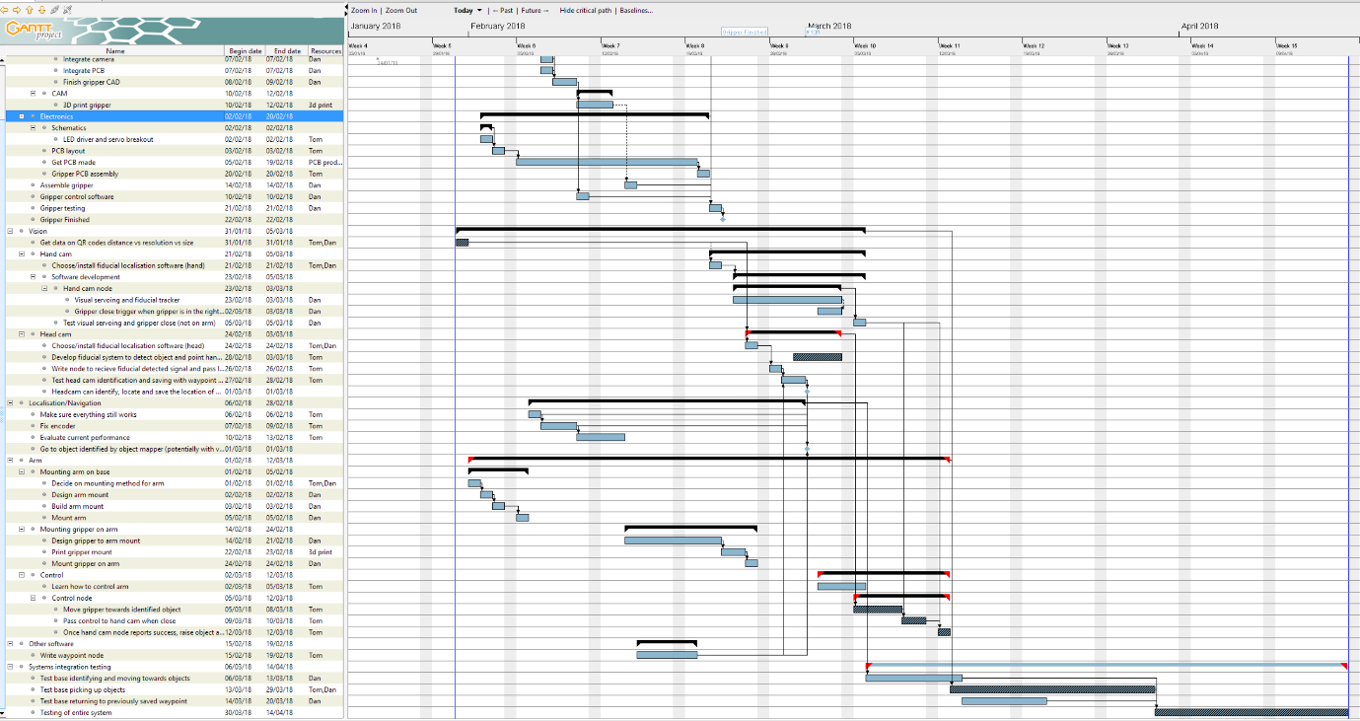

Figure 2

However, we cannot yet implement a fixed CPM methodology due to uncertainty regarding a particular set of subsystems in the robot as mentioned in the ‘Development issue with cascaded camera systems’ section of this document. For this reason, we have decided to bring elements of Adaptive Project Management (APM) methodologies into our management philosophy.

Traditional project management is based on planning well and planning once, at the start of the project. Managerial roles are rigid and focused on the initial plan, and project control is focused around identifying deviations from this plan and getting things back on track. This planning process can take months to fully design and specify a system before development work has been initiated. The APM methodology differs from traditional project management in that planning is expected to be iterated through the project lifecycle with a more flexible and adaptive managerial approach and plans adjusted if deemed necessary. We have decided to take elements from both approaches as we have not managed to lock-down a final solution and strict time management is essential for the completion of this project.

Currently there is a key re-plan scheduled once development work has identified the solution to our cascaded vision system problem. The current critical path is running under the assumption that fractal fiducials are a feasible solution. This is not yet tested. If fractal fiducials prove to be an unsuitable solution, a re-plan will be initiated and the critical path will be re-evaluated. If further technical hang-ups are encountered (or new approaches discovered), and potential solutions outweigh the time cost of a re-plan, plans may be adapted to account for yet-to-be-identified solutions and the critical path will be evaluated again.